JAYA SUPER-SPECIALTY FERTILITY CENTRE &
CENTRE FOR REPRODUCTIVE GENETICS AND IMMUNOLOGY
Dr. PRIYANKA CHEVUTURI MBBS, MS(OBGYN), M. Ch (REPRODUCTIVE MEDICINE AND SURGERY), REG NO: APMC/FMR/129439
FERTILITY AND REPRODUCTIVE MEDICINE DEPARTMENT

FOLLICULAR STUDY
NAME/AGE:
LMP: MENSTRUAL CYCLE NUMBER: DAY 2 CYSTS: Yes No
PLAN: MEDICINES TAKEN: Letrozole 5 mg OD x 5 days (or) Step-up regimen (or) Other

Clomiphene Citrate - 100 mg x 5 days (or) Other

Inj. HMG - Dose 75 mg x days (or) Other

DATE | DAY OF CYCLE |  | RIGHT OVARY | LEFT OVARY |  | ENDOMETRIUM | REMARKS/DECISION
PRE-TRIGGER FOLLICULAR FEATURES:  POST TRIGGER SCAN  ORIENTATION OF UTERUS:  AV RV MP  UCL: cm  CERVIX: cm  FREE FLUID: Yes No  RI : FAVOURABLE: 0.4-0.48  PSV: FAVORABLE: >10cm/sec  VI: FAVOURABLE: 6-20  FI: FAVOURABLE: >35  FV: FAVOURABLE: 3-7.5cm3  VISIBLE CUMULUS: Yes No  VASCULAR NETWORK: Good Poor |  |  |  |  |  |  | Dr. PRIYANKA CHEVUTURI MBBS, MS(OBGYN), M. Ch (REPRODUCTIVE MEDICINE AND SURGERY), REG NO: APMC/FMR/129439  FERTILITY AND REPRODUCTIVE MEDICINE DEPARTMENT
TOTAL MEDICATION TAKEN: |  | FINAL TREATMENT PLANNED  Timed Coitus  IUI  Cancelled cycle |  |  | OUTCOME OF THE CYCLE
IUI SUMMARY
UPT to be done on ______________ morning, mid-stream urine sample. Do not consume excessive amounts of water.
If positive, inform on phone/in person or review the same day by booking an appointment.
If negative, stop medications and visit on Day 2/3 of next cycle.

Dr. PRIYANKA CHEVUTURI MBBS, MS(OBGYN), M. Ch (REPRODUCTIVE MEDICINE AND SURGERY), REG NO: APMC/FMR/129439
FERTILITY AND REPRODUCTIVE MEDICINE DEPARTMENT

WIFE: | HUSBAND:
AGE: | AGE:
MRD: | MRD:
HOSPITAL NUMBER  OF THE COUPLE: | DATE OF IUI:
IUI PROCEDURE  SPECULUM USED:  CUSCO’S SIM’s  VAGINA:  HEALTHY  EVIDENCE OF INFECTION  CERVIX:  HEALTHY ECTROPION  BLEEDING ON TOUCH  PERFORMED WITH:  IUI CATHETER  OUTER ET CATHETER  INNER ET CATHETER  COMPLEXITY OF THE PROCEDURE:  EASY WITH IUI CATHETER  DIFFICULT WITH IUI CATHETER  EASY WITH ET CATHETER  DIFFICULT WITH ET CATHETER  LUTEAL PHASE SUPPORT BEING GIVEN:  Yes No  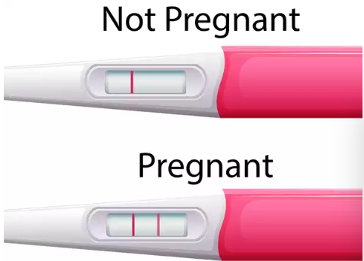 | SEMEN SAMPLE  POST-WASH SAMPLE  Pooled sample: Yes No Method:  Sample preparation time: minutes  Sample ready by:  Sample( micro litre)  Concentration Million/ml  Motility  T P NP IM  PRE-WASH SAMPLE (2) / NA  Bottle issue time:  Sample receiving time:  Sample:  Volume ml  Viscosity Yes No  Conc. Millions/ml  Motility:  T P NP IM  Agglutin -ation Yes No  Grade:  1 2  3 4  Pus cells  PRE-WASH SAMPLE  Bottle issue time:  Sample receiving time:  Sample:  Volume ml  Viscosity Yes No  Conc. Millions/ml  Motility:  T P NP IM  Agglutin -ation Yes No  Grade:  1 2  3 4  Pus cells

